LAB 2 (02/05/25)
Assignment 1:
Code:
import java.util.Scanner;
public class Car {

// Attributes
String make;
String model;
short year;
int price;

// Constructor
public Car(String make, String model, short year, int price) {
this.make = make;
this.model = model;
this.year = year;
this.price = price;
}

// Method to display car details
public void displayCarDetails() {
System.out.println("Car Details:");
System.out.println("Make : " + make);
System.out.println("Model : " + model);
System.out.println("Year : " + year);
System.out.println("Price : Rs." + price);
}

public static void main(String[] args) {
Scanner scanner = new Scanner(System.in); //user input

System.out.print("Enter car make: ");
String make = scanner.nextLine();

System.out.print("Enter car model: ");
String model = scanner.nextLine();

System.out.print("Enter car year: ");
short year = scanner.nextShort();

System.out.print("Enter car price: ");
int price = scanner.nextInt();

Car userCar = new Car(make, model, year, price); // Create Car object

userCar.displayCarDetails(); // Display car details

scanner.close();
}

Output:
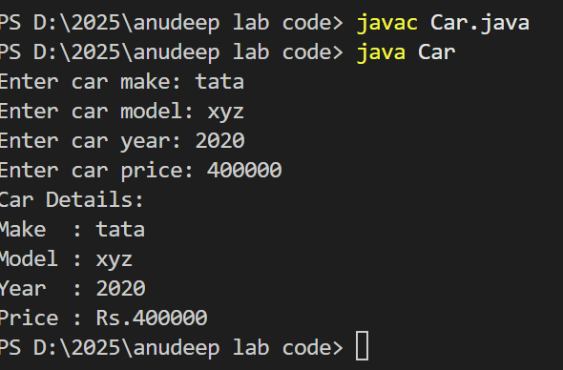

Assignment 3:
Code:
public class Student2{

// Attributes
private String name;
private int age;
private String department;

// Constructor
public Student2(String name, int age, String department) {
this.name = name;
this.age = age;
this.department = department;
}

// Getter and Setter for name
public String getName() {
return name;
}
public void setName(String name) {
this.name = name;
}

// Getter and Setter for age
public int getAge() {
return age;
}
public void setAge(int age) {
this.age = age;
}

// Getter and Setter for department
public String getDepartment() {
return department;
}
public void setDepartment(String department) {
this.department = department;
}
}

Output:
Compilation done and class file created


